Week 9

$$\underset{WORD EMBEDDING}{\underbrace{word\underset{→}{word2vec, GloVe}vector}}→\left\{\begin{aligned}\underset{→}{Euclidean Distance, Cosine Similarity}word similarity \\ clustering \\ generating new data\end{aligned}\right.$$

Motivation
Word classification is more difficult than image classification because text is sequential.

Word embedding
Definition: Word embedding refers to embedding a high-dimensional space with the number of words to a low-dimensional continuous vector space, each word or phrase maps to a vector.
- Good word embedding enables similar semantic words to have closer vector values or cluster together
- Relationship between word embedding & encoder/decoder:
- Word embedding is the process to only convert a word to a vector, not work for encoding or decoding (Neural network does), but may be involved as a support, like
$$encoder: word vector→low-dim embedding/latent space vectors$$
$$decoder:low-dimvectors→output\left(??\right)$$
Different types of decoder outputs:
- P of Nearby words (model: word2vec - skip-gram/input: target word)
- P of Target words (model: word2vec - CBOW/input: nearby word)

3 BAD ways of word embedding (convert a word/phrase to a numerical value):
- Randomly assign a numerical value to each of the word
- Integer Encoding: not good for categorical data without order, because assumes an order may cause poor performance
- One-hot encoding: Pro: a better way of conversion for categorical data – make more sense; Con’s: a) dimension exploding with the increasing number of words b) Assume each word is completely independent – means learning one word won’t help learn how to use the other similar words at the same time c) sparse matrix – useful information is hard to be highlighted in huge amount of data
【what is one-hot encoding? – convert each word as an index, and the total number of the vector is the number of words】【one special example: word “good” and “bad” could have similar low-dim vector values because their surrounding words are the same】
How to create good word embedding?
Target: lower the dimension exploding issue (from above bad ways) + generate target
Method: Apply similar architecture of Autoencoder Architecture -> Encode words into a low-dimensional space, then decode the low-dimensional space into nearby words generations
Note: Antonym words with the same nearby words may have similar word embedding values

Word2Vec
Learning type: self-supervised learning (as no label but augment x as label)
Key: learn a latent space/embedding space(a way of how to convert a word to a vector), and satisfy the closer semantic words have smaller cosine similarity of their embedding vectors

Model 1: CBOW Continuous Bag-of-Word
Input: nearby words, like a sentence miss the target word
Output: a target word/phrase

Model 2: Skip-Gram (more frequently used, more accurate than CBOW)
Input: a target word/phrase
Output: the nearby words within a certain range of context window
How? In code? Related to a pre-4a/pre-4b ipynb of class material
Word2vec Disadvantages: a) ignore the order of the words in a sentence b) can’t handle 1 word with multiple meanings because vectors are trained by nearby words. If the same word in a different semantic environment, the nearby words change, then the word needs to be learned again c) word limitation cause can’t incorporate full context d) slow
Word2Vec Encoder&Decoder purpose: decoder (parameters between hidden layer and output layer) is only for training, to update the encoder, so that model knows which word is more highly likely to after the target word. The encoder (parameters between input layer and hidden layer, also called “word2Vec embedding) is used finally.
Word2Vec embedding Result: words with similar context will have similar embeddings.

GloVe
Input/output/how it works conceptually/
2 measures of vectors:
- Euclidean Distance: the larger means 2 words are not similar (this is a distance)
$$Euclidean Distance = \sqrt[2]{\sum_{i}{{\left(x_{i}-y_{i}\right)}^{2}}}$$
torch.norm(glove[‘cat’] – glove[‘dog’]
- Cosine Similarity: the larger means 2 words are more similar
$$Cosine Similarity = \frac{A∙B}{∥A∥∥B∥}$$
Torch.cosine_similarity( glove[‘cat’].unsqueeze(0), glove[‘dog’].unsqueeze(0))
Downstream tasks: s
- Text understanding: sentiment analysis, text summarization, question answering
- Text generation: translation, sentence completion, create captions
- calculating distance, or clustering

Sentiment Analysis
Purpose: given a piece of text, identify the sentiment that the text conveys
Source: Tweets/Movie review/emails/Feedback
Difficulties in data-cleaning including:
  - Grammer/spelling
  - Different Languages
  - Choice of learning words or characters (like emoticon)
  - Arbitrary length

Coding Details:
Process
$Splitthetweetintoword\left(tokenize\right) → Lookup word vectors in GloVe→Add up words vectors to get the tweet embeddings(i.e. vectors)→input into a Neral Network$

Pro & Cons of
- Architecture: simple, but can’t consider sequential words nature
- Used Training Data: free & short, but needs to clean and no labels
- Ethical Consideration: model also learns the bias
Resolution for not consider sequential data:
- Concatenate each word embedding to a higher-dim and then train with a MLP
  - Disadvantage: dimension explosion and need the fixed length of input
- Concatenate each word embedding and train with a 1-layer CNN
  - Disadvantage: focus only on regional infor, can’t handle long-distance input
RNN
Coding? Check ipynb
Comparing to CNN and MLP, RNN enables variable-sized sequential input and has memory.
Weight sharing in all time steps
tahn as activation functions 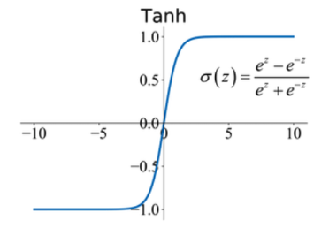

Week 10

Basic RNN (Vanilla RNN) – for classification problems
1-layer RNN is as below
$$input → RNN →output$$
Within each layer of RNN, weights are shared and loop through all sequential data
The difference is there are 2 inputs: last step state and current step input

Mathematical Understanding
Definition: the previous step state and current step input determines the current step state

Initial Hidden State: can be zero vectors

Notation:
$a^{l-1}$: previous step state
$x^{t}$: current step input (each token, or the embedding of each word)
[if the sequential input is a sentence, then in below image, after tokenization, each token is the vector of each word, which means in step 1, the $x^{1}$ is embedding(“the”); $x^{2}$ is embedding(“food”) etc.]
${\tilde{a}}^{l-1}$:$\left[\begin{matrix}a^{l-1} \\ x^{t}\end{matrix}\right]$ this is the concatenation of above previous step state and current step input, only for easier math calculation, no difference in meanings
$W_{hh}$: weight/parameter matrix to calculate previous step state’s contribution to current step state
$W_{xh}$: weight/parameter matrix to calculate urrent step input’s contribution to current step state
h: number of nodes in hidden layer (1 hidden layer; if there are multiple hidden layer, then there are multiple h)
x: numebr of input nodes, also as number of tokenized vectors
$f\left(\right):$ activation function. Here are $tahn$(more used) or $SoftMax$
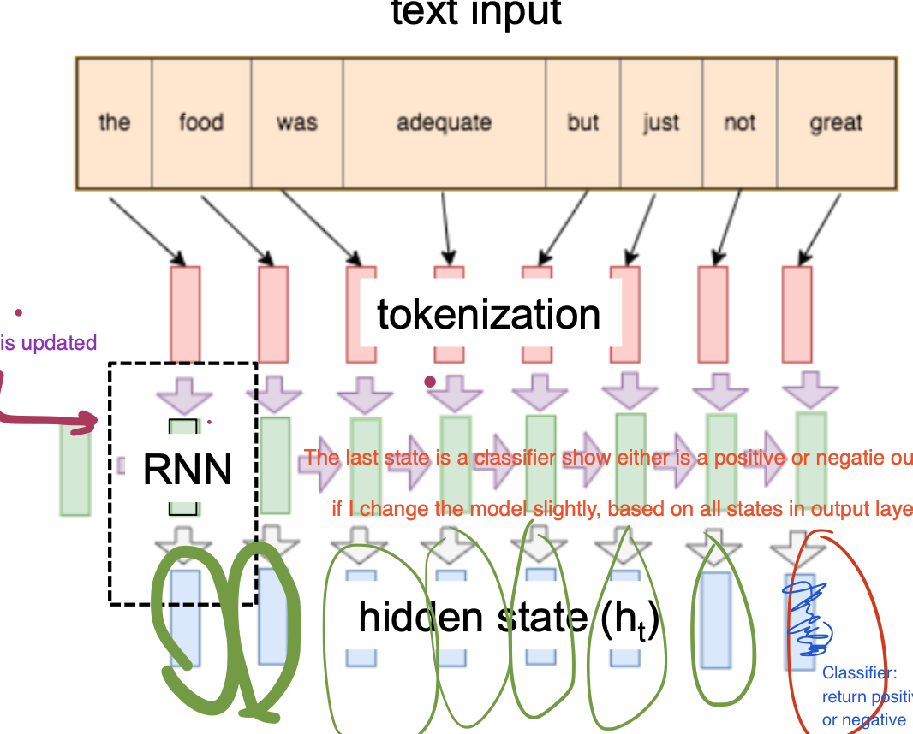
Forward Propagation
$$a^{l}=f\left({ (W}_{hh} W_{xh}) \left[\begin{matrix}a^{l-1} \\ x^{t}\end{matrix}\right] +b^{l}\right)$$
Or write as
$$a^{l}=f\left(W_{hh}a^{l-1}+W_{xh}x^{t}+b^{l}\right)$$
The activation functions are $tahn$ or $SoftMax$, with
$$tahn = \frac{e^{x}-e^{-x}}{e^{x}+e^{-x}} -1<y<1$$
$$softmax = \frac{e^{x}}{e^{x}+1} 0<y<1$$
Backward Propagation
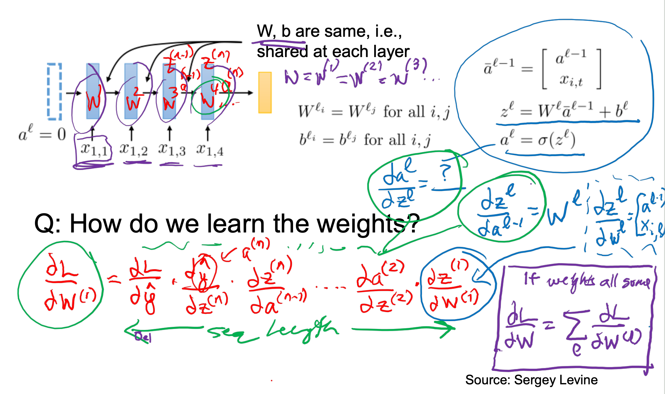
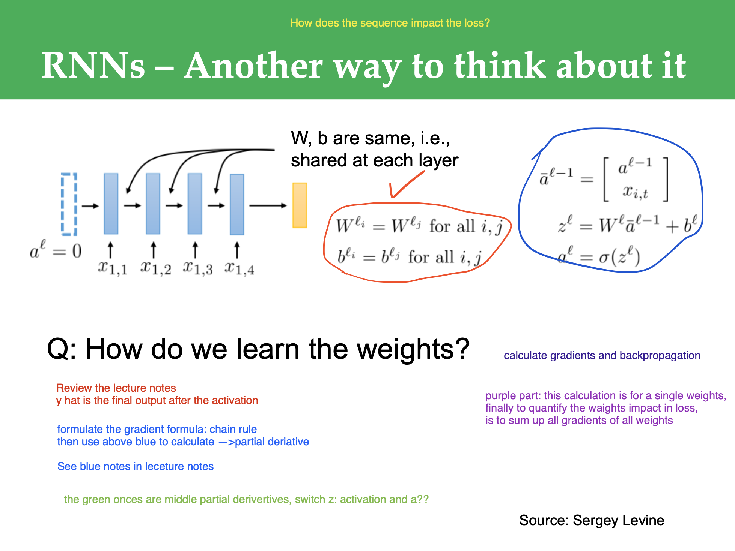

Replace a RNN as a variable-depth networks:
Layer: Each time step in RNN = one layer in MLP
Difference: RNN share weights across all time steps, while MLP has different weights per layer. But back propagation is the same for both, if replace and want to optimize RNN weights, calculate gradients for weights of 1 time step in RNN about Loss, finally times this with the number of time steps. (see above lecture slides)

Variable Length Input Handling
Add zero paddings (i.e. zero vectors) to the layer before the first state.
Purpose: since all these sentences(i.e. inputs) will be fed into RNN, which requires the same length of inputs. to map the fixed size input of following RNN
Disadvantages:
- Good at capturing the recent information, but not the long-term information
- Since the RNN is like a MLP (both are linear forwards and same backward propagation training approach), so may cause gradients exploding or vanishing
[note: the differences are RNN takes sequential data, and consider previous state; MLP input a chunk of data and only look at current step input]
Solution – Skip Connection

LSTM Long Short-Term Memory
1 layer LSTM
Forget Gate
  - Definition: how much percentage of the cell state from previous time step will be kept
  - Calculation – use Sigmoid (since this is a %)
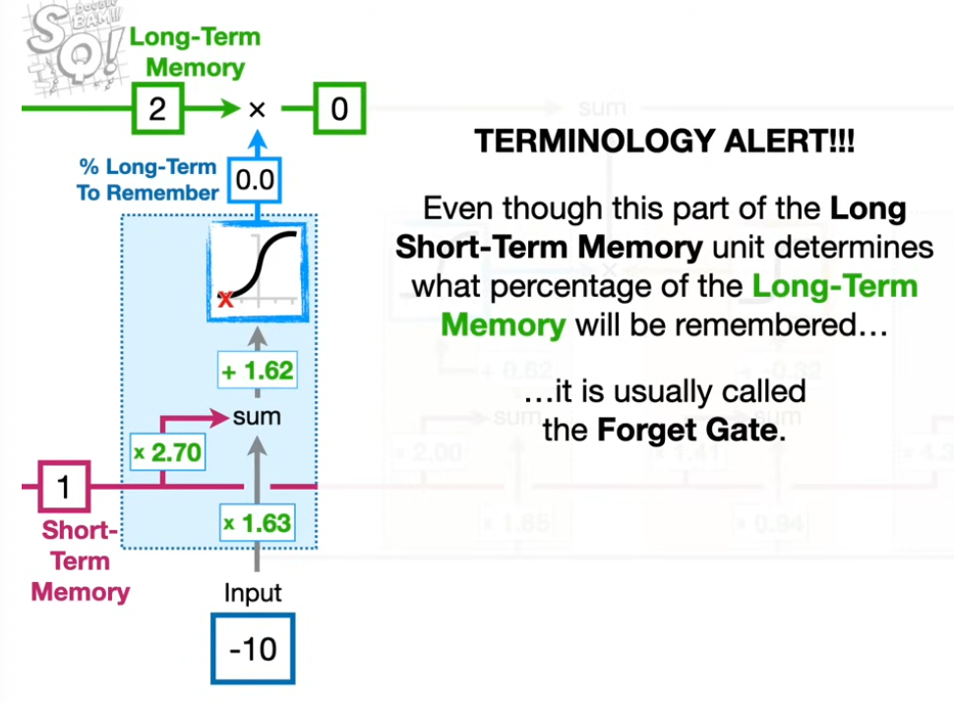

Multi-layer RNN / Deep RNN
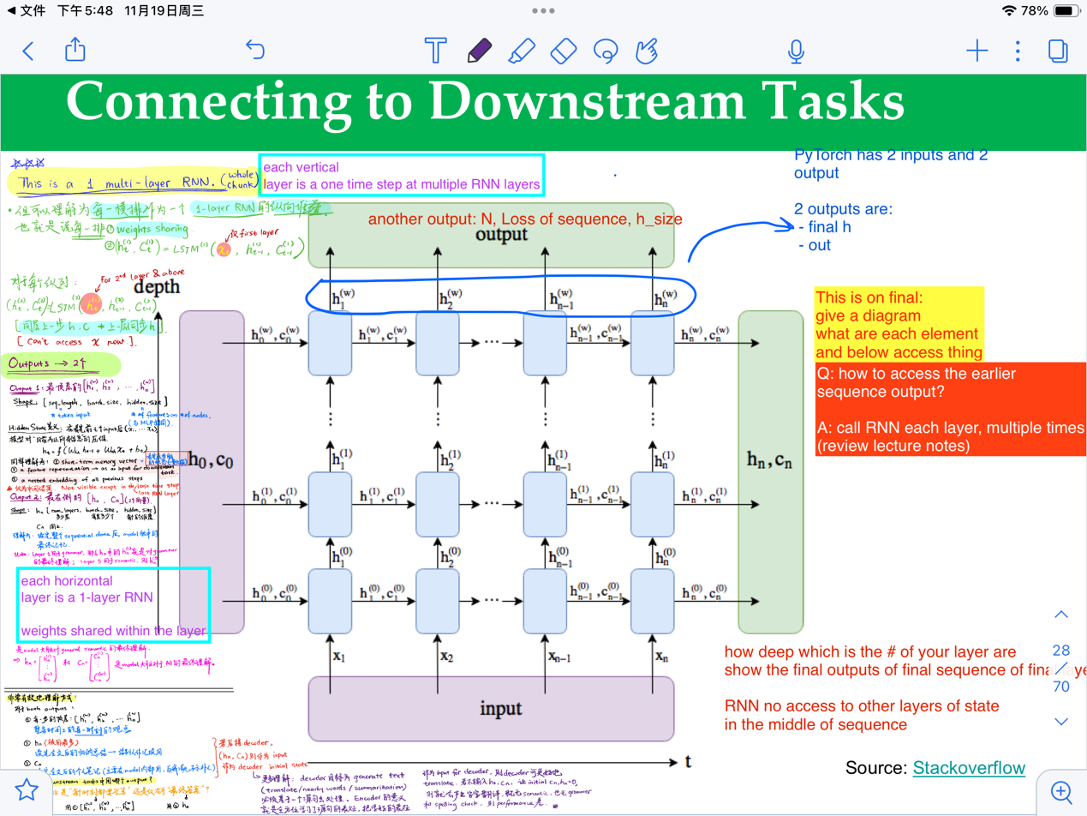
Also please be very familiar with the terminology and mathematical example using LSTM in this video! Very helpful
https://www.youtube.com/watch?v=YCzL96nL7j0
CNN and RNN share weights (CNN – kernel is the shared weights; RNN – share weights across all time steps), MLP have different weights for each layer.

RNN – for Text Generation
Similarity and Difference with RNN for prediction:
  - Similarity: both process 1 token at each time step
  - Difference:
    - RNN for prediction: hidden state represents all tokens read so far (past and present)
    - RNN for generation: hidden state represents all tokens to be generated (future but not strictly future – actual input tokens)
RNN for text generation Training Flow in General – Each time step repeats all process below except initializing h0 – 有多少个token就有多少次classification
- Input: token embeddings
$$token=preprocess\left(tokenizedinput\right)$$
  - Initialize the hidden state h0 with <BOS> - a hard-coded embeddings, not 0
This is also the information to the model to inform a sentence starts
- Hidden state update with last hidden state and current input
$$hidden_{t}=hiddenUpdate\left(x_{t},h_{t-1}\right)$$
more specific in math representation:
$$h_{t}=tanh\left(W_{xh}x_{t}+W_{hh}h_{t-1}+b_{t}\right)$$
where
$$tanh = \frac{e^{x}-e^{-x}}{e^{x}+e^{-x}}$$
A specific example:
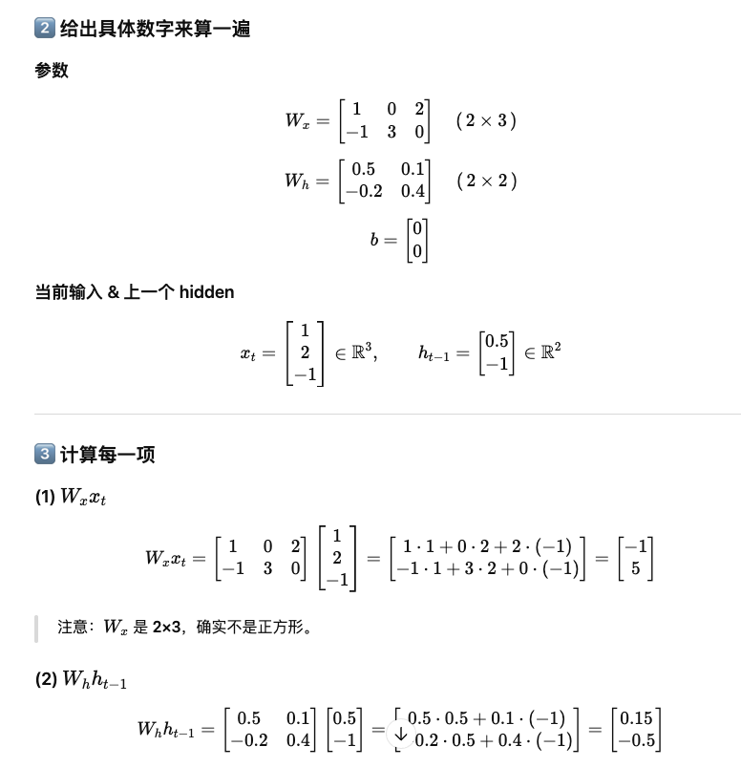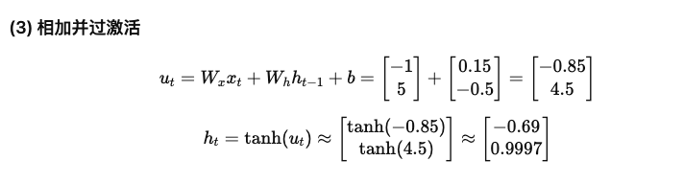
h_t represents the model understanding based on input read so far
- Token distribution – probabilities of all tokens in the token list as the next token (multiple classification problem)
$$token distribution=predition\left(lasthiddenstate\right)$$
- Token sampling – get one of the words based on token distribution (don’t have to be argmax due to diversity requirement of text generation)
$$tokenSampling=sampling\left(tokendistribution\right)$$

A few sampling methods（数字例子要掌握！）
- Greedy Search – big disadvantage: no diverse in text generation, flat
  - 跨度：1 time step
  - How: after the token distribution of this time step, get the argmax token; then move to the next time step, repeat
- Beam Search (an alternative for exhaustive search)
  - 跨度：k time steps
  - How: Track k time steps and get the prediction combination of the largest multiplies probabilities
Example区分beam search and greedy search: k=2
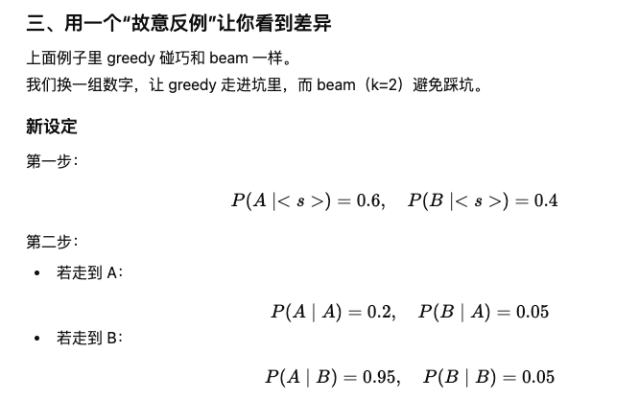
Greedy search decision: AA; Beam search decision: BA
- Temperature
  - 跨度：-
  - How: only impact logits, and cause impact on softmax prob.
$$p=softmax\left(\frac{logits}{temperature}\right)$$
Where
$\left(\frac{logits}{temperature}\right)$ is a scaled logit
The larger the temperature, the rare words are highly likely to be generated because high temperature lower the gap of token probability. While the smaller the temperature, the more conservative the model is because it exaggerates token probabilities.
Some other notes in training:
  - For RNN for text generation, input is a token, label is the next actual token from input, prediction is a classification problem to sample a token from the token distribution by based on the last hidden state.
  - So Loss function is cross entropy
  - Teacher forcing
  - What: instead of using the output/prediction from last time step as the next step input, we use the actual next token as next step input
  - Why: correct model timely, not predict very far away answers; stable training; converge quickly
  - When: mostly in decoder/training section of language model

RNN for generation Applications:
- Generate C code
- Time-series data: demand forecasting
- Physiological signal generation
- Combining with CNN (image representation) + RNN (image captioning)

Transfer Learning

Bidirectional RNN
What: run 2 RNN asbelow
Why: disambiguate the meaning of a word, need information from both directions

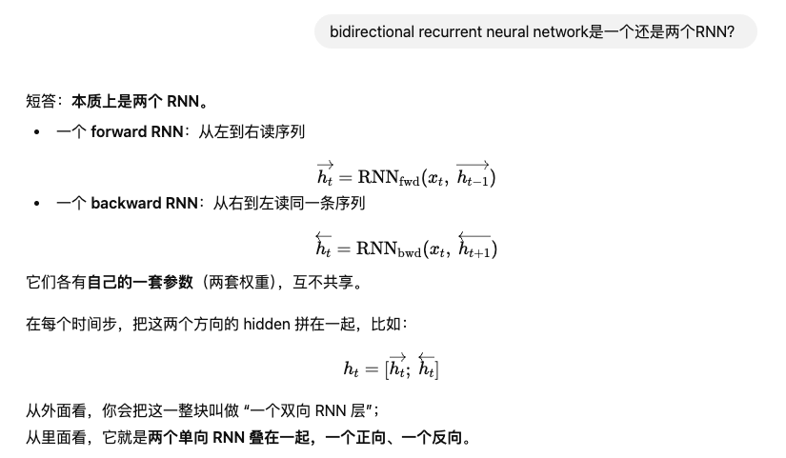

Week 11
Recap on RNN:
A real-world question: we know RNN can be a generative model of text. How to make it generate words start from “A cute puppy...”?
Answer: in training/decoder, use teacher forcing, treat the “A cute puppy” as actual tokens feed into the first few hidden states.

